#### **Installation tutorial of Arduino IDE**

#### **Installation steps in Windows system**

****1. Download Arduino IDE****

Download link of Arduino IDE：<https://www.arduino.cc/en/software>

Open the download link as shown in the figure below.Because the Arduino IDE 2.0 is not easy to use, we download the Arduino IDE1.8.19 version. If your computer is installed with Windows system, click Windows ZIP file.

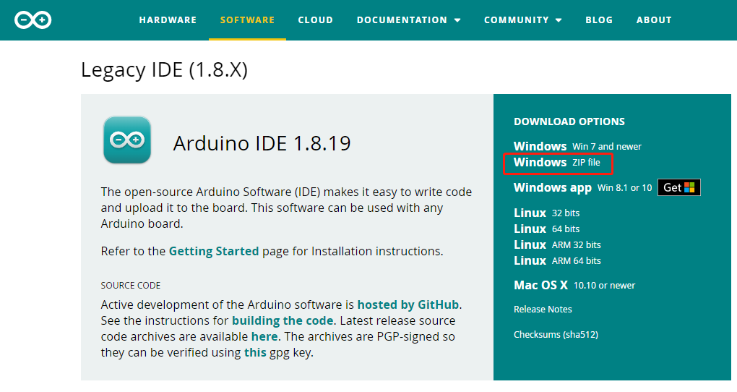

****2. After downloading, put it in your usual storage disk and decompress it.****

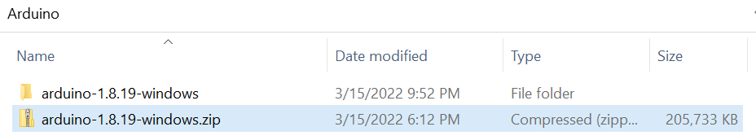

****3. After decompression, the installation is completed. Then double click arduino.exe to open Arduino IDE.****

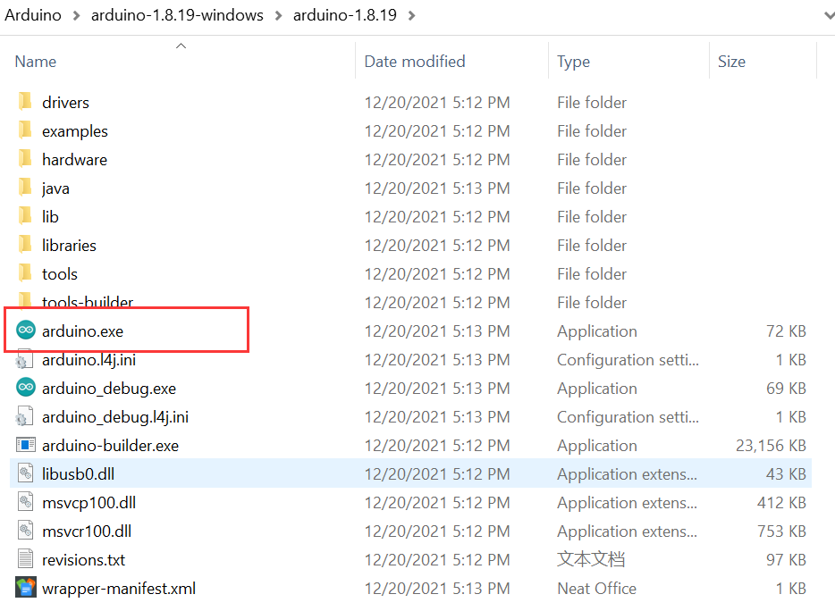

1. ****Interface introduction of Arduino IDE****

